Report Title: Adding commenting Feature to CSE 3100 Project.
Theory: A commenting feature enhances user engagement by allowing visitors to share their thoughts, feedback, and experiences. This feature is essential for a cooking blog as it encourages readers to discuss recipes and share tips. This report outlines the implementation of a commenting system in a Django-powered cooking blog.
Implementation Steps
1. Define the Comment Model
Create a Comment model linked to the Post model to store user comments.
class Comment(models.Model):
user = models.ForeignKey(User, on_delete=models.CASCADE)
post = models.ForeignKey('Post', on_delete=models.CASCADE, related_name='comments')
content = models.TextField()
created_at = models.DateTimeField(auto_now_add=True)

def __str__(self):
return 'Comment by {} on {}'.format(self.user.username, self.post.title)

2. Update Views to Handle Comments
Modify the view to process comments and display them alongside the corresponding post.
@login_required
def add_comment(request, post_id):
post = get_object_or_404(Post, pk=post_id)
if request.method == 'POST':
content = request.POST.get('content')
if content:
Comment.objects.create(user=request.user, post=post, content=content)
return redirect('DisplayPost', post_id=post.id) # Ensure 'display_post' matches your URL name
return HttpResponseForbidden("Invalid request.")

3. Create Templates for Comment Display
Modify the post_detail.html template to display comments and the form.
<div class="container vh100">
<div class="row mt-5">
<div class="col-lg-8">
<h3>Comments</h3>

<!-- Display comments -->
<div class="comment-section mt-4">
{% if comments %}
{% for comment in comments %}
<div class="comment mb-3">
<p><strong>{{ comment.user.username }}:</strong> {{ comment.content }}</p>
<small class="text-muted">{{ comment.created_at }}</small>
</div>
{% endfor %}
{% else %}
<p>No comments yet. Be the first to comment!</p>
{% endif %}
</div>

<!-- Add Comment Form -->
<form method="post" action="{% url 'AddComment' post.id %}" class="mt-4">
{% csrf_token %}
<div class="form-group">
<textarea name="content" class="form-control" rows="4" placeholder="Write your comment here..." required></textarea>
</div>
<button type="submit" class="btn btn-primary">Post Comment</button>
</form>
</div>
</div>

Testing Screenshots:
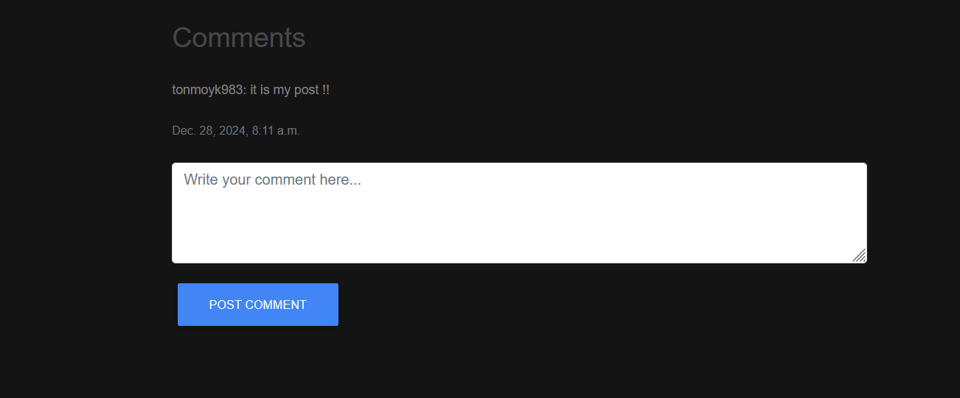
Conclusion
The commenting feature was successfully implemented, providing users with a way to interact with the cooking blog. This addition promotes engagement and builds a community around the blog content.

